****NOTICE OF A COMPLETE APPLICATION AND OF A PUBLIC**

# **MEETING CONCERNING A PROPOSED AMENDMENT TO**

# **ZONING BY-LAW N° 20-2018 (D14-146)**

**Take notice** that the Municipal Council of the Corporation of the Town of Hawkesbury will hold a public meeting on the

**28th of October 2024, at 6:00 p.m.** **at Town Hall, 600 Higginson Street** to consider a proposed Amendment to Zoning

By-law N° 20–2018 under Section 34 of the *Planning Act*, R.S.O. 1990, c.P.13.

**The purpose of the application** is to rezone Part of Lot 8 on Registered Plan M-16, an unaddressed vacant lot on Higginson Street, to consider the site as one lot for zoning purposes to allow for the construction of residential townhouses and low-rise apartment dwellings. The subject property is currently zoned “Residential Zone 4 with Exception (R4-X)”. The proposed Zoning By-law Amendment would add a new R4-exception Zone that would treat Part of Lot 8 as one lot for Zoning By-law purposes to allow the construction of the proposed residential dwellings.

**The project consists of** the development of townhouse and apartment dwellings, which are permitted in the R4 zone. The application to amend Zoning By-law N° 20–2018 will be specific to the property described as Part of Lot 8 on Registered Plan M-16, in the Town of Hawkesbury, County of Prescott.

**If a person** or public body would otherwise have the ability to appeal the decision of the Council of the Corporation of the Town of Hawkesbury to the Local Planning Appeal Tribunal but the person or public body does not make oral submissions at a public meeting or make written submissions to the Council of the Corporation of the Town of Hawkesbury before the Zoning By-law is passed, the person or public body is not entitled to appeal the decision.

**If a person** or public body does not make oral submissions at a public meeting, or make written submissions to the Council of the Corporation of the Town of Hawkesbury before the zoning by-law is passed, the person or public body may not be added as a party to the hearing of an appeal before the Local Planning Appeal Tribunal unless, in the opinion of the Tribunal, there are reasonable grounds to do so.

**This meeting will take place in person**, anyone wishing to attend the meeting must confirm their attendance at the following email address: [infoplanning@Hawkesbury.ca](mailto:infoplanning@Hawkesbury.ca), **no later than October 25, 2024, at 4:00 p.m**. We kindly ask you to send any comments or questions in advance to the above-mentioned email address. This meeting will be available for your viewing on our YouTube channel a few days after the meeting.

**If a person** wishes to be notified of the Council of the Corporation of the Town of Hawkesbury’s decision on the proposed Zoning By-law Amendment, they must make a writt[en request to the Planning](mailto:infoplanning@hawkesbury.ca) Department by email at [infoplanning@Hawkesbury.ca](mailto:infoplanning@Hawkesbury.ca).

**Additional information** relating to the proposed amendment to Zoning By-law N° 20–2018 is available to the public by contacting the Town’s Planning Department at the following email: [infoplanning@Hawkesbury.ca](mailto:infoplanning@Hawkesbury.ca).

**KEY PLAN**

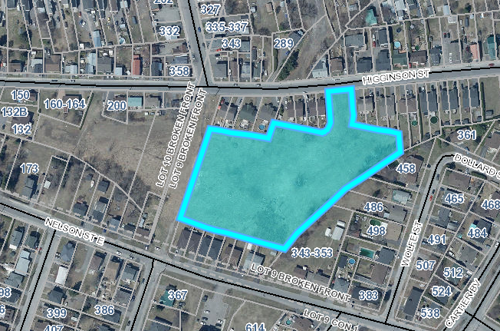

Dated at the Town of Hawkesbury

This 7th day of October 2024

Jillian Simpson, MCIP RRP

Planner

FOTENN Consultants

[simpson@fotenn.ca](mailto:simpson@fotenn.ca)

[www.hawkesbury.ca](http://www.hawkesbury.ca)

Lands targeted by the application.

If the format of this document is inadequate, please contact the Technical Services – Urban Planning at [infoplanning@Hawkesbury.ca](mailto:infoplanning@Hawkesbury.ca), and the municipality will provide, to the best of its abilities, the required assistance.