
NOTICE OF A PUBLIC MEETING CONCERNING A PROPOSED

CHANGE OF STREET NAMES (BRUNEAU AND PILON)

Take notice that the Municipal Council of the Corporation of the Town of Hawkesbury will hold a public meeting on the 12th of November 2024, at 6:00 p.m. at Town Hall, 600 Higginson Street with the intent to pass a by-law at the November 12, 2024, regular Council meeting to approve the renaming of existing public streets Bruneau and Pilon to Zoning By-law N° 20–2018 under Section 34 of the Planning Act, R.S.O. 1990, c.P.13.
The purpose of the renaming is to correct projected street names in a future subdivision development south of Lafrance Crescent due to existing street names known as Bruneau Street and Pilon Street, to have no two streets name the same.
If a person or public body would otherwise have the ability to appeal the decision of the Council of the Corporation of the Town of Hawkesbury to the Local Planning Appeal Tribunal but the person or public body does not make oral submissions at a public meeting or make written submissions to the Council of the Corporation of the Town of Hawkesbury before the Zoning By-law is passed, the person or public body is not entitled to appeal the decision.

If a person or public body does not make oral submissions at a public meeting, or make written submissions to the Council of the Corporation of the Town of Hawkesbury before the zoning by-law is passed, the person or public body may not be added as a party to the hearing of an appeal before the Local Planning Appeal Tribunal unless, in the opinion of the Tribunal, there are reasonable grounds to do so.

This meeting will take place in person, anyone wishing to attend the meeting must confirm their attendance at the following email address: infogreffe@hawkesbury.ca, no later than November 8, 2024, at 4:00 p.m. We kindly ask you to send any comments or questions in advance to the above-mentioned email address. This meeting will be available for your view on our YouTube channel a few days after the meeting.

If a person wishes to be notified of the Council of the Corporation of the Town of Hawkesbury’s decision on the proposed Zoning By-law Amendment, they must make a written request to the Planning Department by email at infogreffe@hawkesbury.ca.

Additional information relating to the proposed amendment to Zoning By-law N° 20–2018 is available to the public by contacting the Town’s Planning Department at the following email: infogreffe@hawkesbury.ca.

Other Considerations
Project information can be found on the Town’s website at www.hawkesbury.ca under the Town Hall tab on the home page, in the Urban Planning section and by clicking on the public meetings tab.

KEY PLAN
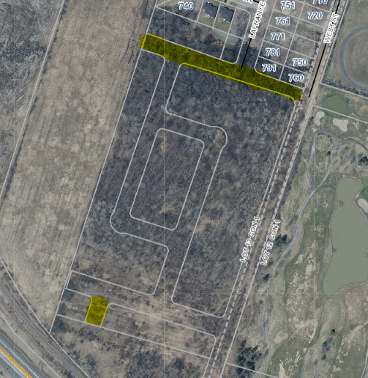
Dated at the Town of Hawkesbury
This 23rd day of October 2024

Annie Rochefort, Deputy Clerk
infogreffe@hawkesbury.ca
www.hawkesbury.ca

Lands targeted by the request.

If the format of this document is inadequate, please contact the Clerk’s Department at infogreffe@hawkesbury.ca, and the municipality will provide, to the best of its abilities, the required assistance.

