
NOTICE OF THE PASSING
OF OFFICIAL PLAN N°8 AND A ZONING BY-LAW AMENDMENT
BY-LAWS N°59-2024, N°60-2024
(OPA N° 8 D09-46/D14-144)

TAKE NOTICE that the Municipal Council of the Corporation of the Town of Hawkesbury passed By-law No. 59-2024 at a meeting held on Monday, September 23, 2024, under Section 17 of the Planning Act, R.S.O. 1990, c. P.13, as amended.

AND TAKE NOTICE that the Council of the Corporation of the Town of Hawkesbury passed By-law N° 60-2024 at a meeting on Monday, September 23, 2024, under Section 34 of the Planning Act, RSO 1990, c. P.13, as amended.

DESCRIPTION OF LANDS: The subject lands are municipally known as 430 County Road 17 and legally described as Parts 5 and 6 on Plan 46R-6D20, Lot 4, Concession 1, formerly in the Geographic Township of West Hawkesbury now Hawkesbury, County of Prescott. A Key Map is provided below.

Note that this is a second Notice in relation to Amendments for this property. Following the identification of a procedural error, the previous By-laws were repealed and replaced with the present By-laws.

THE PURPOSE AND EFFECT OF THE OFFICIAL PLAN AMENDMENT (BY-LAW N° 59-2024) IS TO:
- Repeal the previously approved By-law amending the Official Plan of the Town of Hawkesbury and replace with this new By-law.

- Redesignate the subject lands from Regional Commercial Policy Area to Trade and Industry Policy Area.

- The effect of the Official Plan Amendment is to permit the development of a new light industrial development on the subject lands.

THE PURPOSE AND EFFECT OF THE ZONING BY-LAW AMENDMENT (BY-LAW N° 60-2024):
- Repeal the previously approved By-law amendment the Zoning By-law of the Town of Hawkesbury and replace with this new By-law.

- Rezone the subject lands from Regional Commercial (CR) to a site-specific Industry One zone (E1-xx).

- The effect of the Zoning By-law Amendment is to rezone the lands to conform to the proposed Official Plan Amendment to permit the development of a light industrial development on the subject lands whereas the site-specific zoning would permit employee and visitor parking to be located in the exterior side yard and would permit a shared driveway width of 10.0 metres.

EFFECT OF PUBLIC SUBMISSIONS ON THIS DECISION: The Town heard comments of support for the amendments from the applicant and their planning representative and heard no comments against the proposed redesignation and rezoning to permit the new light industrial use on the subject lands. Council considered these statements of support in rendering their decision.

TAKE NOTICE that any person or public body will be entitled to receive notice of the decision of the approval authority if a written request to be notified of the decision is made to the approval authority.

AND TAKE NOTICE that the approval authority is the United Counties of Prescott Russell, Planning and Forestry Department located at 59 Court Street, P.O. Box 304, L’Orignal, Ontario K0B 1K0.

ADDITIONAL INFORMATION relating to the Official Plan N° 8 By-law N° 59-2024 and Zoning By-law N° 60-2024 is available for review during normal office hours (between 8:00 a.m. and 4:00 p.m.) at the Planning Department located at 600 Higginson Street, Hawkesbury.

Personal information that accompanies a submission will be collected under the authority of the Planning Act and may form part of the public record which may be released to the public.

DATED AT THE CORPORATION OF THE TOWN OF HAWKESBURY
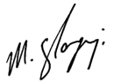
THIS 25th DAY OF SEPTEMBER, 2024.

__________________________
Mike Szilagyi, MCIP OUQ
Email: szilagyi@republicurbanism.com
www.hawkesbury.ca

Key Map

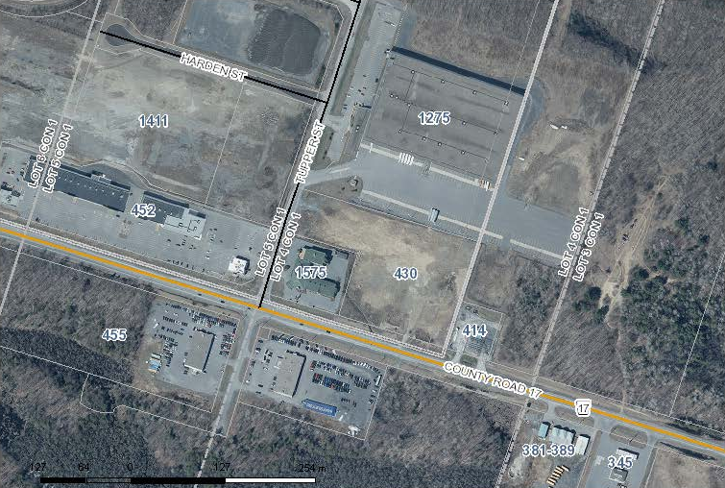

Lands affected by the application

